From The Desk of The Robotsmiths

Thank you for your Husky A200 order! As part of the integration, we have prepared this quick reference sheet for you and your team detailing your specific configuration.

Operational Tips

For best performance, it is advised that the batteries are charged regularly. If the vehicle begins halting unexpectedly, doing one or more of the following may improve performance:

* Reducing motor power draw by lowering acceleration, turning in place less, or limiting the grade of terrain being traversed.
* Reducing peripheral power draw by unplugging or otherwise shutting off devices which are not in use.

Network Information

Your Husky has been equipped with an USB wifi adaptor and the mini-ITX computer has been configured as a bridged network. The internal eth0 interface has been set to 192.168.1.11. The wifi interface is configured via wlan0, for wireless connection via DHCP to a router or a base station. To configure the mini-ITX for your wireless network connect via ssh. To do so, connect an Ethernet wire to one of the two available ports on the Mini-ITX. Set a static IP address in the range 192.168.1.x, netmask 255.255.255.0 then ssh in.

ssh [administrator@192.168.1.11](mailto:administrator@192.168.1.11)

password : clearpath

Then in a command prompt launch the “wicd-curses” utility

wicd-curses

At this point a window will list all the available wifi netowrks. Use the up and down arrows to select your network, then press the right arrow when your network is highlighted.

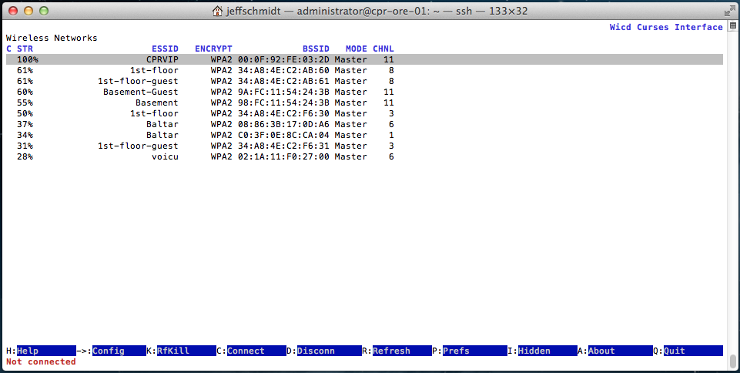

A new window will appear, where you may enter your wifi network and password :

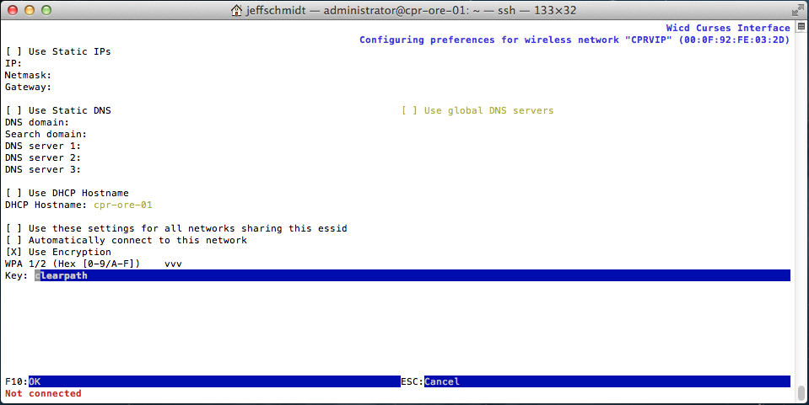

In the “Key” field enter the wifi password. If you would like the computer to automatically connect to this network, ensure the “Automatically connect to this network” box is selected.

Once the wifi connection is configure as desired press “F10”. Type “C” (capital C) to connect to your network. If successful, the computer’s wifi IP will be listed at the bottom. Type “Q” (capital Q) to exit the wicd-curses utility. The computer should now be able to access your network via the wifi connection.

| Parameter | Robot 1 |
| --- | --- |
| Mini-ITX IP | 192.168.1.11 |
| Mini-ITX name | cpr-ksu-03 |
| Mini-ITX login | administrator/clearpath |

Software Information

* We recommend creating a catkin workspace at the root directory of your Husky’s computer. From here, custom ROS packages may be launched manually, or automatically on startup. To launch a ROS node on startup simply place the relevant launch file in the /etc/ros/hydro/husky-core.d directory. Make sure you also place a “source” command inside of /etc/ros/setup.bash so that the system knows where to find your catkin workspace.
* The robots are pre-configured to start a joystick interface node for teleoperation. At any time, the wireless gamepad may be used to drive Husky. Shift the switch on the top of the gamepad to “X”, hold down the “A” button, and use the left analog stick to control Husky.
* Husky’s upstart job runs on system startup. It can be started in the background with sudo service husky-core start and stopped with sudo service husky-core stop. It may be launched in the foreground using **sudo husky-core-start**. Your team should not typically need to start or stop the service—just use roslaunch to launch additional nodes which interface with the persistent ones.

Remote Connection to Husky

Your robots are set up with Ubuntu 12.04 and ROS Hydro. For maximum compatibility, we recommend your ROS workstation be configured the same way. Suggested steps:

* Download and install Ubuntu: <http://cdimage.ubuntu.com/precise/dvd/current/>
* Set up ROS Hydro: <http://wiki.ros.org/hydro/Installation/Ubuntu>
* Install the Desktop packages for Husky:  
    
  sudo apt-get install ros-hydro-husky-desktop

For a wired connection, set your laptop’s Ethernet interface to a static IP in the 192.168.1.x subnet. Then, connect to an available network port on the Mini-ITX computer with an Ethernet patch cable.

For wireless, connect to the same network as the Husky. Your PC should be assigned an IP automatically, which you can check using ifconfig or similar tools.

If you have ROS installed on your laptop, you can connect it to the Master running on Husky:

sudo route add –net 192.168.1.11 netmask 255.255.255.255 gw cpr-ksu-03

export ROS_MASTER_URI=http://192.168.1.11:11311

export ROS_HOSTNAME=$(hostname).local

rostopic list

If you don’t have ROS or would prefer to work directly on the Husky PC, you can SSH in. Note that you will not be able to using GUI tools such as rviz over an SSH connection.

ssh administrator@192.168.1.11

rostopic list

**CH Robotics IMU**

The IMU data may be accessed via the following command. Type Control-C to return to the prompt:

rostopic echo imu/data

**Visualizing with rviz**

Husky may be visualized using **rviz**. First install the Husky Desktop package on your own computer:

sudo apt-get install ros-hydro-husky-desktop

After declaring the Husky as ROS master (see above), launch rviz:

roslaunch husky_viz view_robot.launch

Once rviz launches, wait a few moments for the model to render. You can rotate the model using your cursor, and zoom in or out by scrolling up or down. The Husky itself may be driven directly from rviz by changing to Interact mode. In this mode, arrows appear around the Husky model. Drag the arrows to send movement commands to Husky.

More information on rviz is available here: <http://wiki.ros.org/rviz>

Information on husky_viz is available here: <http://wiki.ros.org/husky_viz>

**“Shore Power” Upgrade**

Your Husky is equipped with a “Shore Power” upgrade, allowing it to be powered from any AC wall outlet for an indefinite amount of time. This is useful during the development process, as you can leave the Husky powered on all day without worrying about the battery running down. Simply plug in the included AC power cord to the outlet between the two left wheels, and turn on the main Husky power.

**Learning**

If you are new to using ROS, be sure to go through the ROS tutorials available on the ROS wiki page:

<http://wiki.ros.org/ROS/Tutorials>

For great practical examples using ROS, check out the ROS 101 tutorials:

<http://robohub.org/tag/ros101-tutorial/>

Please contact our support team directly at **support@clearpathrobotics.com** if you have any further questions. For ROS-specific questions, we recommend visiting **answers.ros.org**, which we also keep an eye on.

Sincerely,

The Robotsmiths